Buckeye

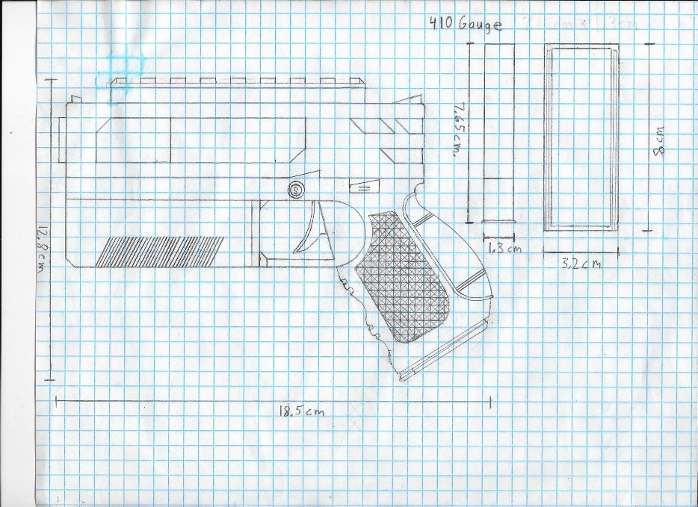

**Description:** Semi-automatic shotgun pistol that is great for close range combat such as clearing rooms.

**Dimensions (LxWxH meters):** 0.185m x 0.032m x 0.128m

**Weight (kilograms):**

**Weapon Type:** Pistol

**Fire Modes:** Semi-automatic

**Ammo Types:** [410 Gauge](../../Asset%20Design%20Documents/Ammo/410%20Gauge.docx)

**Fire Rate (rounds/minute):** 48 rpm

**Magazine Capacity:** 4 rounds

**Maximum Ammo Capacity:** 32 rounds

**Sights:** Name1[link to Sight Design Document], Name2[link]

**Side-Barrels:** Name1[link to Side-Barrel Design Document], Name2[link]

**Under-Barrels:** Name1[link to Under-Barrel Design Document], Name2[link]

**Other Attachments:** Name1[link to Attachment Design Document], Name2[link]

**Material Description:** Carbon Fiber <Image>, Black Steel <Image>

**Concepts:**

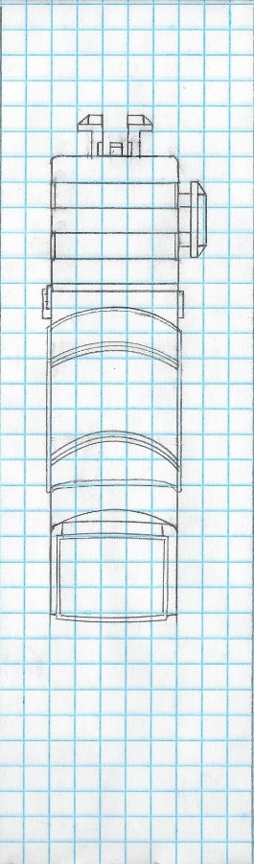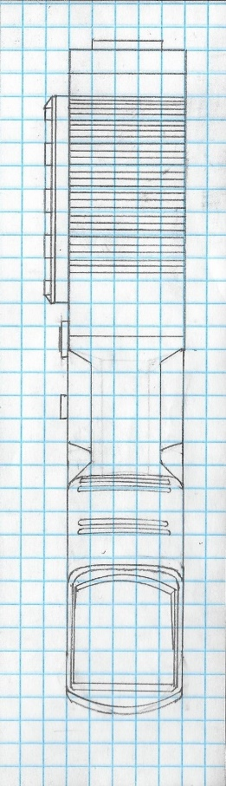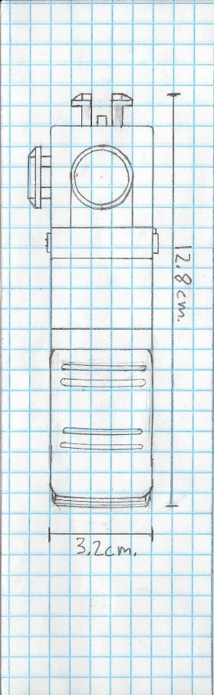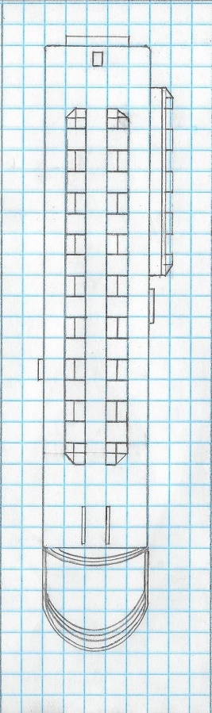

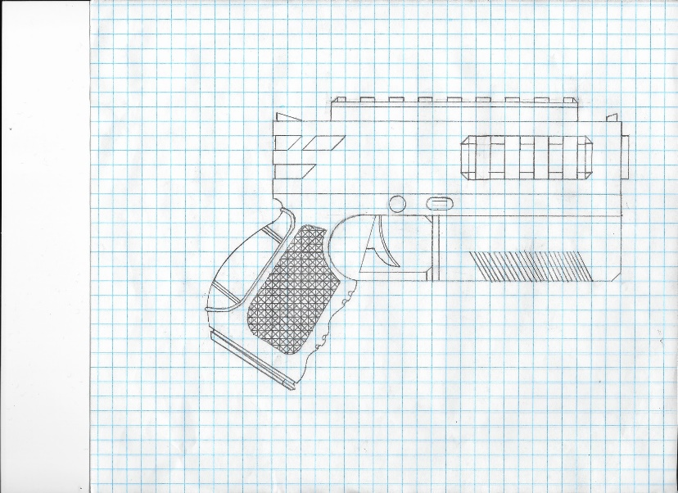

**Other Comments:** Major recoil, but usually a one-shot kill in torso and head in close range.